SYNAPSE
Centralised Healthcare Data Platform: R&D Requirement and Proposed Direction
Prepared by: Tejaswi Gawai, IT Software & Application Specialist | Lifecare Diagnostics | Status: Proposal for review

1. Purpose of this note
This note summarises my understanding of the Synapse requirement, the system flow I propose to prove through a proof of concept (POC), and the decisions I need from leadership before moving beyond R&D.

2. Summary
- Patient reports today are scattered across sources and formats (digital PDFs, scanned PDFs, images, lab values). Staff cannot easily see one patient's history in one place.
- Synapse aims to collect these reports, keep the original, extract the key data, organise it by patient and date, make it searchable, and use AI to summarise it.
- An initial report-ingestion R&D/POC has been completed. The next step is to extend it into a full end-to-end POC, using synthetic or de-identified data only, as directed.
- No production deployment is proposed at this stage. Several points (Section 8) need to be confirmed first.

3. Objective
To turn scattered, unstructured healthcare information into a structured, searchable and traceable data repository that authorised users can query and that an AI layer can summarise.
Core flow: Collect → Store → Extract → Structure → Organise → Search → Summarise → Interpret

4. Proposed system flow
Stage | What happens | Why it matters
1. Ingestion | Reports enter from Lifecare and external sources; the original file is stored unchanged. | Keeps the source of truth.
2. Format detection | System decides: digital PDF, scanned PDF/image, text, or numeric data. | Each type needs different handling.
3. Extraction | Text extraction for digital PDFs; OCR for scans. | Converts documents into readable text.
4. Structuring | Key fields (patient, date, report type, test, result, unit, reference range, source) are extracted into a fixed schema and validated. | Makes data searchable and comparable.
5. Storage | Structured data in a database, linked to the original report. | Enables traceability.
6. Chronology | Each patient's results are arranged by date (e.g. Hemoglobin over 2024–2026). | Gives history, not isolated reports.
7. Search | Search by patient, test, date, source, or plain-language question. | Central report library.
8. AI layer | Summaries, trends and assisted interpretation on retrieved data only. | Saves time; always traceable to source.

Flowchart: how a report moves through Synapse
Yellow = original file kept. Red = validation step. Green = end user. The dashed line shows that every result can be traced back to its original report.
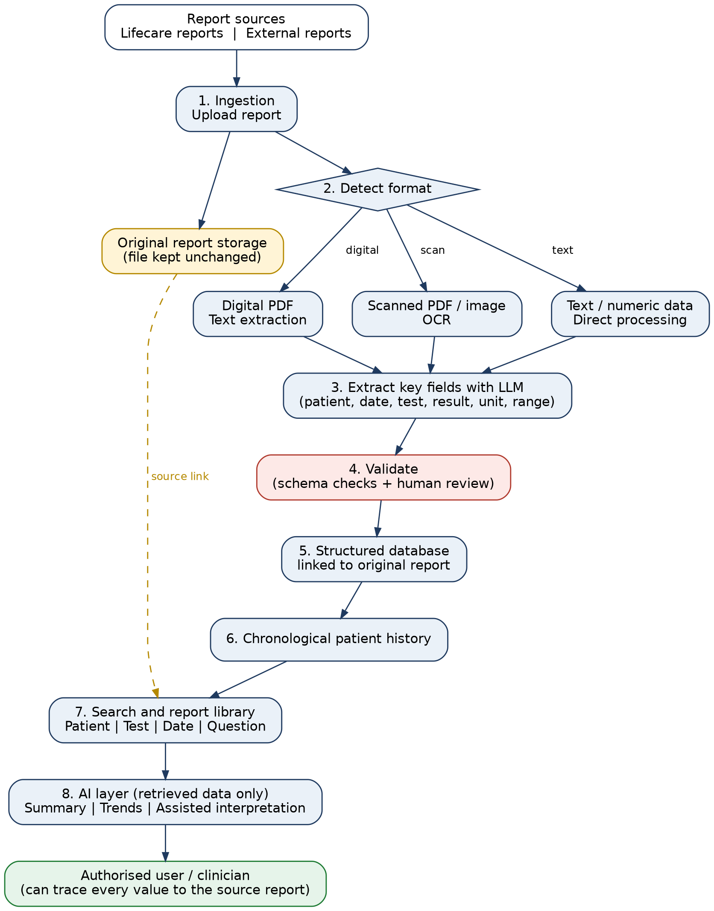

5. Key design principles
- Traceability: every extracted value and AI statement links back to the original report.
- Two layers of data: original source file plus structured extracted data.
- Human validation: AI interpretation is decision support only and is subject to clinical validation and safeguards.
- Privacy first: no real patient data in R&D; access control and encryption to be designed before any real data is used.

6. Proposed POC scope
Upload report → PDF/OCR processing → extract information → structure data → store → search → generate summary.
Success will be judged on: extraction accuracy on synthetic reports, correct patient/date linking, search returning the right records, and summaries that match the source. Target figures and timelines will be agreed with leadership.

7. Possible later phases (after POC is validated)
- Multiple data sources and automated ingestion
- API / LIMS (Sufalam) integration, subject to confirmation of technical feasibility
- Patient timelines and parameter tracking
- Advanced search and AI-assisted analysis; workflow automation

8. Decisions and validation needed
# | Point | Question to be answered
1 | Data sources | Which Lifecare and external sources come first?
2 | Report formats | Which PDF / image formats must be supported?
3 | Patient identification | How will reports be linked to the correct patient (ID, name, phone, other)?
4 | Data fields | Which fields must be structured first?
5 | Storage | Where will databases and original files be hosted (cloud / on-premise)?
6 | AI scope | Summary only, or also trends and interpretation?
7 | Validation | Who verifies extracted data and AI output, and how?
8 | Security & compliance | Access control, encryption, and review under applicable data-protection requirements.
9 | Integration | What are the LIMS/Sufalam integration needs and constraints?

9. Risks
- Extraction errors on poor scans or varied lab formats could produce wrong values; mitigated by validation and traceability.
- Patient mismatch across reports; mitigated by defining patient identification rules early.
- AI output may be mistaken for medical advice; mitigated by clinical review and clear labelling.
- Data privacy; mitigated by synthetic data now and a security design before real data.

10. Request to leadership
- Approval to extend the existing POC to the end-to-end flow above, using synthetic/de-identified data.
- A short discussion to confirm the decisions in Section 8, especially data sources, patient identification and AI scope.
- Nominated clinical and operations contacts to review sample report formats and validate outputs.

